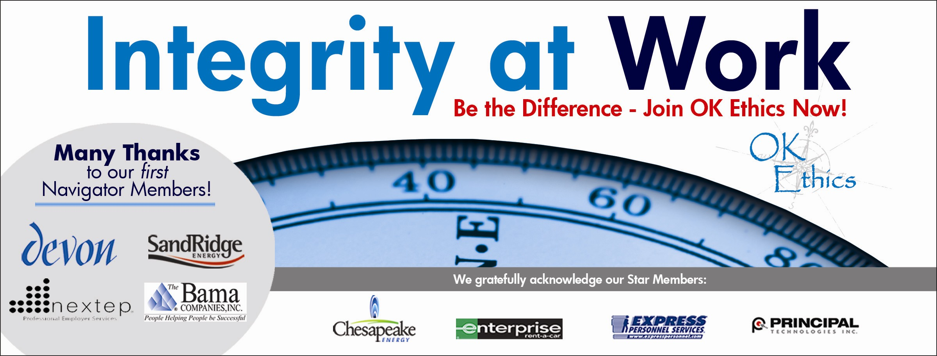

Oklahoma Business Ethics Consortium
Tulsa Chapter

February 28, 2008 – 11:30 a.m. to 1 p.m.

- Welcome and special chapter awards (11:45 -11:50) John Stancavage, Tulsa World
The Tulsa chapter of Ok Ethics wants to thank some of its Legacy team members for their efforts in 2007.

II. Compass Awards call for entries and testimonial (11:50 – noon) Rob Martinek, Bama
These annual awards recognize outstanding ethical practices at Oklahoma companies. Nominations now are being accepted at www.okethics.org. A luncheon to honor the finalists and recognize the winners will be held April 28 in Oklahoma City. Last year, the Tulsa-based Bama Cos. was among the winners.

III. Introduction of guest speaker (Noon) John Stancavage

IV. Keynote address: David Rutkauskas, Beautiful Brands (Noon – 12:50)

David Rutkauskas is the founder, president and CEO of Beautiful Brands International (BBI), a Tulsa-based restaurant development company, responsible for the successful launch of worldwide, franchised brands including Camille’s Sidewalk Cafe, Coney Beach and FreshBerry.

V. Membership update Whitney Mathews

VI. Closing remarks (1 p.m.) John Stancavage

Ok Ethics

UPCOMING EVENTS

Tulsa Chapter

- March 27 – Rick Brinkley, CEO, Better Business Bureau of Tulsa, “Recognizing and Avoiding Business Scams.”
- April – No chapter meeting. OK Ethics Compass Awards in Oklahoma City, April 28.
- May 29 – Panel discussion: “When Good Companies Go Bad.” Speakers TBA.
- June 26 – Clifton L. Taulbert, president and founder, The Building Community Institute.

OKC Chapter

- March 12 – “Religion’s Impact on Ethical Decision-Making in the Workplace”
Panel of clerics lead by moderator, Dr. Vince Orza, Dean of Meinders School of Business, OCU
- April – No chapter meeting. OK Ethics Compass Awards in Oklahoma City, April 28.
- May 14 – Panel discussion: Oklahoma Attorney Generals. More information TBA.

To register for a Tulsa event, or see a list of Oklahoma City or Norman chapter meetings, go to our Web site at www.okethics.org

PLEASE HELP US CONTROL COSTS BY LEAVING YOUR NAME TAG HERE!

NOTE: Members of the Oklahoma Business Ethics Consortium frequently share information concerning various issues and developments that may have legal implications. The discussions, commentary, and handouts at Consortium meetings or presentations to other organizations are for general informational purposes only. They cover only some aspects of the subject topic, and do not constitute a complete legal analysis of the topic or how it might apply to any particular set of facts. Before taking any action based on information presented by a Consortium member, participants are encouraged to consult a qualified attorney. The observations and comments of presenters at Consortium meetings and networking are the views and opinions of the presenter and do not constitute the opinion or policies of the Consortium or any of its members. Please note that speakers are advised in advance of OkEthics policy against politicking, preaching, self-promotion and profanity.

OkEthics

We always are seeking new members.

Join today – You can make a difference!

Corporate Level
NAVIGATOR – $7,500 Includes 16 memberships; prepaid for all OkEthics events – including annual Compass Award

STAR – $5,000 Includes 8 memberships; prepaid for all OkEthics events – including annual Compass Award

HORIZON – $2,500 Includes 8 prepaid meals

LEADING – $1,200 Includes 2 prepaid meals

FRONTIER – $350 Includes 8 memberships; no meals

Individual Level

Trailblazer = $500 (Includes 1 prepaid meal)

Scout = $75 (Individual membership, no meals)

For more information on membership, go to www.okethics.org

